Team Members: Anas Elhadidy, Eizat Mushtaq, Faisal Khan, Milan Ghori
Employee Benefit management System
Brief UC’s

Revision History
Version | Date | Description | Author
1.0 | 10/01/2018 | First draft of brief use cases  Comments:  - Login is not a User-Goal use case, as mentioned many times in class and in the book. UCs start with verbs and contain the user goal (pretty good, but some need work) "selects", "uses", "manages" etc. on associations don't help here (roles will be displayed in Domain Model)  - Take another look at chapter 28 for additional information on use case relationships (includes, extends). | Milan Ghori
1.1 | 11/05/2018 | Second draft of brief use cases  Updates:  - Primary actor identified for each use case  - Updated the description to understand the goal of each use case  - Use case diagram updated. | Eizat mushtaq

Table of contents
No. | Contents | Page No.
1. | UC Diagram | 3
2. | UC Text  2.a Maintain Profile  2.b Configure System  2.c Make Election  2.d Maintain Account for Employee  2.e Check Status  2.f Validate Employee Information  2.g Generate BI Reporting  2.h Notify Vendors  2.i Notify Payroll  2.j Summarises Account  2.k Handle Payment Authorization  2.l Manage Vendors | 4  4  4  5  5  5  5  6  6  6  6  8

Use Case Diagram:
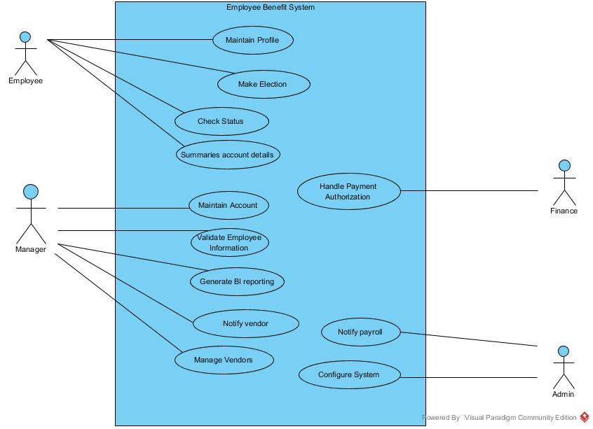
Figure: Overview of System

UC Text

Use case 1: Maintain profile

Primary actor: Employee

An employee does maintain profile. The primary goal of this use case is to view and edit details of an employee. An employee performs this use case to enter his information and save in database. He can also edit his details. The admin creates an account for the employee and gives him access to the application. The Employee logs in to the application and enters his information into the database. After logging in to the system, he will see a portal giving an option to view his profile. This gives him access to edit and delete details in this profile. This information is stored in the database which can be accessed by the management.

Use case 2: Configure System

Primary Actor: Admin

An admin does configure system. Initial installation of the system requires several dependencies, such as installing the database driver, and several options of database platforms, and the kind of OS based on the product’s owner’s interests and construct modules for SSH transfer protocol. Additionally, the system will create a dedicated system admin, where the user name and password are defined by the user who is running this process from the prompt.

Use case 3: Make Election

Primary Actor: Employee

An employee does make election. The primary goal of this use case is to enroll for company provided benefits. He can choose three different elections eligibilities; Open enrolment (OE), Qualified Life Event (QLE), and New Hires (NH).

Use case 4: Maintain Account for Employee

Primary Actor: Admin

An admin does maintain account for employee. Using this use case, an admin creates certain access, update and revoke protocols to the system. At a security point of view, access given to the employee must be restricted to only current employee’s and not ex-employees.

Use case 5: Check Status

Primary Actor:

An employee does check status. The goal of this use case for an employee is to view his enrolment status. This option gives him the capability to check the status of an election such approval, expiration date, and beneficiaries enrolled under a specific benefit.

Use case 6: Validate Employee Information

Primary Actor: Manager

The manager does validate employee information. The management can either approve or deny certain elections in this use case for an employee or a beneficiary after verifying their documents. The management has certain restrictions to handle qualified life event. They must verify certain documents before allowing an employee to register for the qualified life event.

Use Case 7: Generate BI reporting

Primary Actor: Manager

The manager does generate BI reporting. The goal of this use case is to develop to view several managerial reports that are meaningful for the business, such count of employees that are enrolled with specific vendors, or amount of money that the employee or the employer contributed too.

Use case 8: Notify Vendors

Primary Actor: Admin

The Admin does notify vendor. The goal of this use case is to notify a vendor with the list of employees that have selected the vendor’s plan, which eliminates the previously followed manual process of notifying the vendors.

Use case 9: Notify Payroll

Primary Actor: Admin

The Administrator does notify payroll. The goal of this use case is that the administrator updates payroll system and notify payroll staff to streamline payroll deductions for such benefits of an employee.

Use case 10: Summarises Account

Primary Actor: Employee

The employee does summaries account. The goal of this use case is to show the employee his total salary and deduction after enrolling in any election.

Use case 11: Handle payment Authorization

Primary Actor: Finance

The Finance does Handle Payment Authorization. The goal of this use case is to give Finance an option to view the election form of an employee and gives authorization to the payment. Using this use case Finance gets full control to accept or deny the benefits he is about to enrolled. This way the financial management can track the amount the company has to pay for certain employee.

Use case 12: Manage Vendors

Primary Actor: Manager

The manager does manage vendor. The goal of this use case is to remove or add a vendor. If the vendors go out of business or many be there is some problem with certain employee. Management can add, update, and delete vendors to facilitate employee’s elections, payroll deductions, and data exchange.

